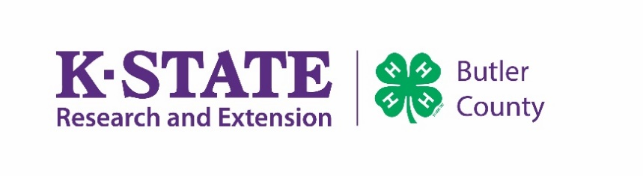

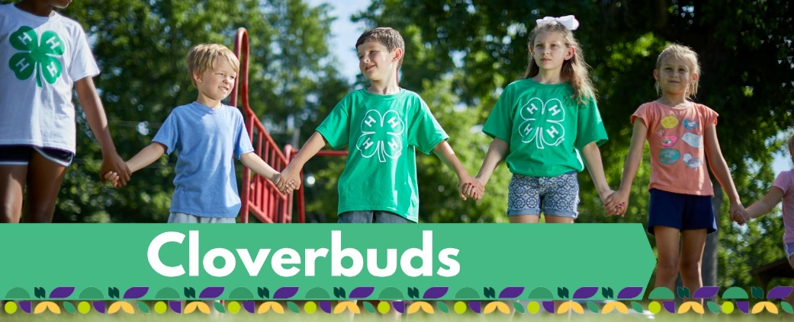

TO: Butler County 4-H Cloverbud Members

FROM: Madeline Wallace, CEA, 4-H & Youth Development, & Charlene Miller, Director/Ag Agent

DATE: May 26th, 2026

RE: 2026 Butler County Fair Projects for Cloverbuds

Dear 4-H Cloverbud Members,

We hope you are excited for the 2026 Butler County Fair! Entries look different for Cloverbud members than our regular 4-H members! The 4-H Cloverbud program is an exciting and enriching non-competitive way for young children to begin their 4-H journey, laying the groundwork for lifelong learning and active participation.
Please read below carefully to help you get on the right track for County Fair participation!

Cloverbuds have the opportunity to participate in 2 different non-competitive events at the Fair.

- Fashion Revue Shopping in Style– Please refer to pages 38 – 40 in the Butler County Fairbook.
  - This event gives young members the opportunity to model an outfit in a non-competitive environment. Youth will be asked questions such as: "Why did you choose this outfit?" Where will you wear your outfit? etc. The questions will be provided to Cloverbud members prior to the judging, so they can practice them beforehand if they choose. We want this to be a fun event that they enjoy.
  - Cloverbuds will receive a participation ribbon.
  - Pre-entries will be done through Fair Entry at http://butlerks4h.fairentry.com by 11:59 p.m. June 22nd. No late entries will be accepted.
    - 4-H Members – SIGN IN with your 4-H Online Account

- Cloverbud Show and Share – Refer to page 78 in the Fairbook.
  - No animals are allowed per 4-H Policy
  - Make or bring as many projects as you would like
  - This is a non-competitive event where 4-H’ers can share their favorite subject area; photography, foods, arts and crafts, etc.
  - There is no pre-entry for this, and Cloverbuds will come to the Show and Share at the Fair. Saturday, July 18th, from 11:00 a.m. – 12:00 p.m. in the South Room of the 4-H building.
Please remember, the only pre-entry is for the Cloverbud Fashion Revue. You cannot pre-enter in any other project!

If you have any questions, please call our Office at 316-321-9660. We are happy to help you!
This institution is committed to providing equal opportunity for participation in all programs, services, and activities. Program information may be available in languages other than English. Language access requests and reasonable accommodations for persons with disabilities, including alternative means of communication (e.g., Braille, large print, and American Sign Language), may be requested by contacting the event contact , Madeline Wallace, four weeks prior to the start of the event at mgwallac@ksu.edu or 316-321-9660. Requests received after this date will be honored when it is feasible to do so. Language access services, such as interpretation or translation of vital information, will be provided free of charge to limited English proficient individuals upon request.
Kansas State University is an equal opportunity provider and employer.

Kansas State University Agricultural Experiment Station and Cooperative Extension Service

K-State Research and Extension is an equal opportunity provider and employer.

